Project Report: E-Commerce Sales Analysis Report
1. Title
E-Commerce Sales Report .
The objective of this project is to analyze and visualize the sales data of popular Indian e-commerce platforms like Amazon, Flipkart, Myntra, etc., to derive meaningful insights about order distribution, customer demographics, and sales performance.

Tools Used
- Excel - For data cleaning, transformation, and dashboard creation
- Power Pivot & Charts - For dynamic visualization and pivot-based analysis
- Data Source - Microsoft Simulated e-commerce data (Orders, Gender, Region, Products, etc.)

Dataset Description
Order ID ? Unique ID for each order
Customer ID ? Unique ID for each customer
Customer Name ? Name of the customer
Gender ? Gender of customer (Men/Women/Transgender)
Age ? Age of customer
Age Group ? 20+, 40+ classification
Order Date ? Date of order placement
Month ? Month of order
Platform ? E-commerce site (Amazon, Flipkart, etc.)
Product Category ? Category of product ordered
Quantity ? Number of units ordered
Amount ? Total order amount
Ship State ? State where order was delivered

Dashboard Features
The dashboard includes the following visuals:
- Sales by Platform
- Top 5 Performing States
- Order Status Breakdown
- Gender & Age Distribution
- Men vs Women Sales
- Order vs Sales Analysis
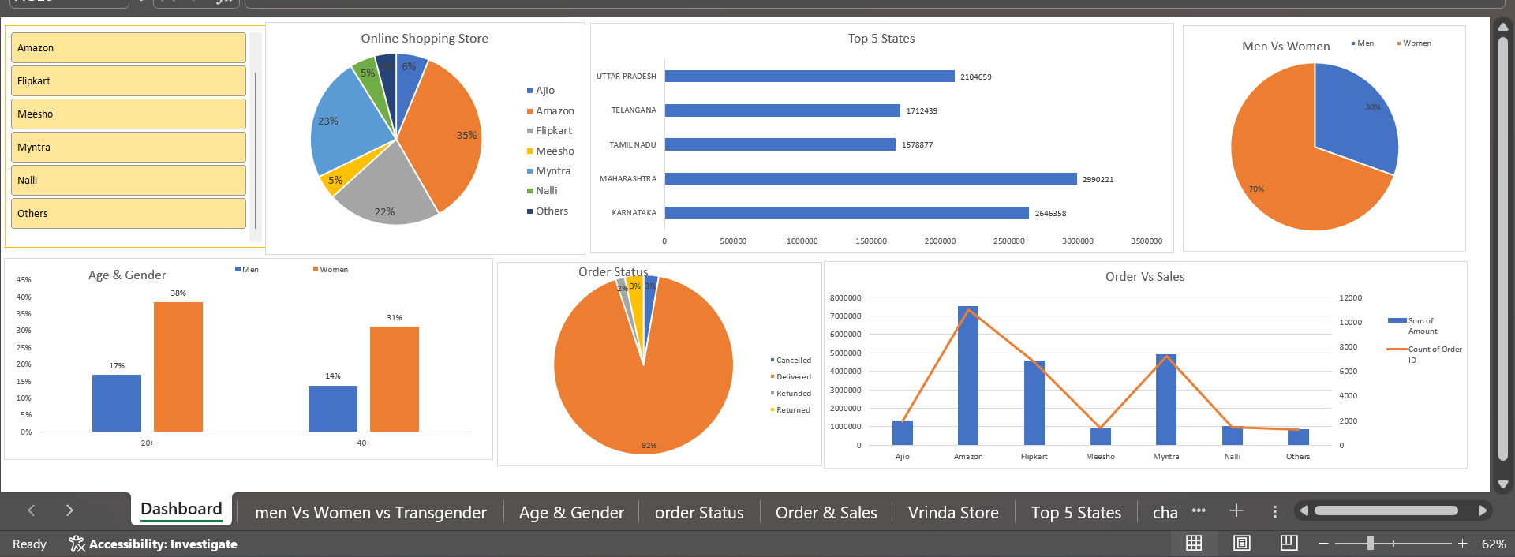

Key Insights
- Amazon and Myntra contribute the highest to total sales.
- Most customers belong to the 20+ and 40+ age groups.
- Women customers represent 70% of the total order volume.
- Maharashtra, Karnataka, and Uttar Pradesh are top-performing states.
- Delivered orders make up 92% of total orders, with a small percentage being refunded or cancelled.

Conclusion
The dashboard offers valuable insights into customer behavior, regional performance, and sales trends. It can help businesses better understand which platforms and demographics drive the most revenue and adjust marketing or logistics strategies accordingly.

Future Scope
- Integrate with real-time MySQL data using Python.
- Use Power BI or Tableau for more dynamic visualizations.
- Perform customer lifetime value and churn analysis.

Submitted by -------
Name : Amit Kumar sah
Semester : 6^{th.}
Domain : Data Analytics
ERP Id : 6602977
Group Name : G2

